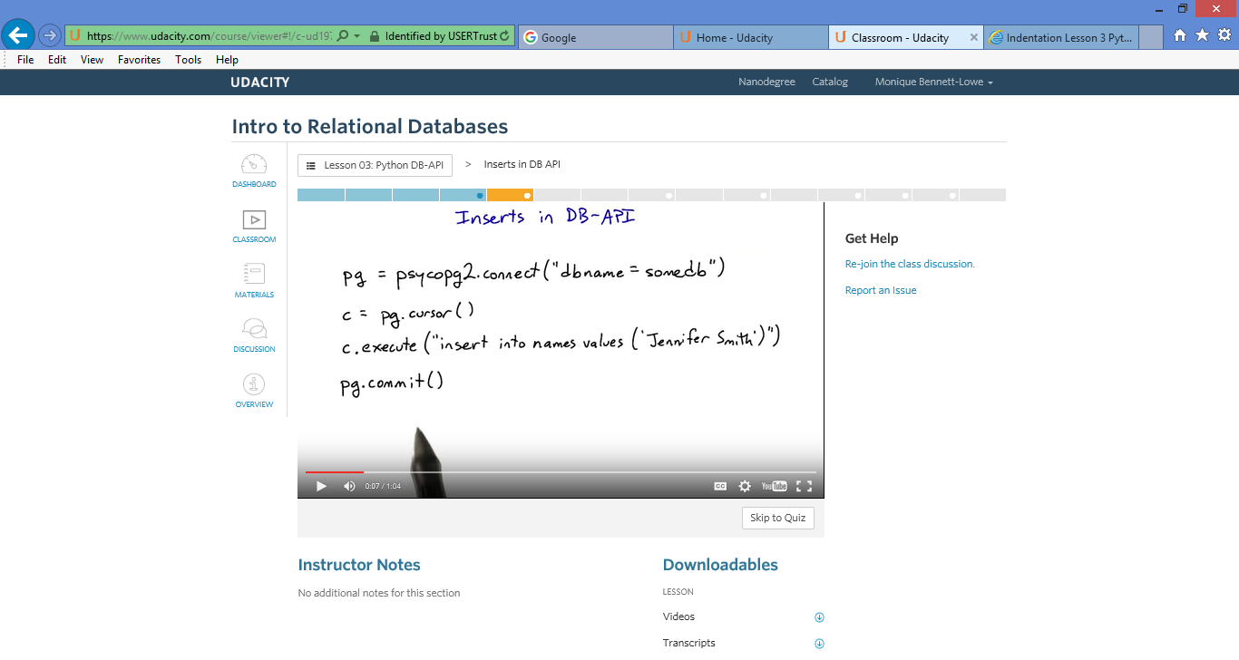

Vagrant halt
Vagrant up
Vagrant SSH
cd forum > forum $ python forum.py
http://localhost:8000

Error Message – Spam Cheese section

Reinstalled psycopg2.

I noticed that I'm able to view the forum in the browser and type input; however, when I hit post, I get A server error occurred. Http 500.

I'm assuming my refresh wasn't working. The error message above is due to additional quote.

10.0.2.2 - - [03/Oct/2015 03:31:14] "POST /post HTTP/1.1" 500 59
Traceback (most recent call last):
File "/usr/lib/python2.7/wsgiref/handlers.py", line 85, in run
self.result = application(self.environ, self.start_response)
File "forum.py", line 96, in Dispatcher
return DISPATCH[page](env, resp)
File "forum.py", line 79, in Post
forumdb.AddPost(content)
File "/vagrant/forum/forumdb.py", line 39, in AddPost
(content,))
ProgrammingError: syntax error at or near "It"
LINE 1: INSERT INTO posts (content) VALUES (''It''s my posts that''s...

I didn't receive this error the first time and didn't edit any code to achieve.

#
# Database access functions for the web forum.
#

import time
import psycopg2

## Database connection
DB = []

## Get posts from database.
def GetAllPosts():
DB = psycopg2.connect("dbname=forum")
c = DB.cursor()
c.execute("SELECT time, content FROM posts ORDER BY time DESC")
#c.execute("UPDATE posts SET content = 'cheese' WHERE content LIKE '%spam%';")
'''Get all the posts from the database, sorted with the newest first.

Returns:
A list of dictionaries, where each dictionary has a 'content' key
pointing to the post content, and 'time' key pointing to the time
it was posted.
'''
posts = ({'content': str(row[1]),
'time': str(row[0])} for row in c.fetchall())
#for row in c.fetchall())
#posts.sort(key=lambda row: row['time'], reverse=True)
DB.close()
return posts

## Add a post to the database.
def AddPost(content):
DB = psycopg2.connect("dbname=forum")
c = DB.cursor()
c.execute("INSERT INTO posts (content) VALUES ('%s')",
(content,))
#c.execute("UPDATE posts ")
DB.commit()
DB.close()
'''Add a new post to the database.

Args:
content: The text content of the new post.
'''
t = time.strftime('%c', time.localtime())
DB.append((t, content))

The shared directory is located at /vagrant
To access your shared files: cd /vagrantB
Last login: Sat Oct 3 01:28:38 2015 from 10.0.2.2
vagrant@vagrant-ubuntu-trusty-32:~$ cd /vagrant
vagrant@vagrant-ubuntu-trusty-32:/vagrant$ python forum.py
python: can't open file 'forum.py': [Errno 2] No such file or d
vagrant@vagrant-ubuntu-trusty-32:/vagrant$ cd forum
vagrant@vagrant-ubuntu-trusty-32:/vagrant/forum$ python forum.p
Serving HTTP on port 8000...
Traceback (most recent call last):
File "/usr/lib/python2.7/wsgiref/handlers.py", line 85, in ru
self.result = application(self.environ, self.start_response
File "forum.py", line 96, in Dispatcher
return DISPATCH[page](env, resp)
File "forum.py", line 54, in View
posts = forumdb.GetAllPosts()
File "/vagrant/forum/forumdb.py", line 30, in GetAllPosts
posts.sort(key=lambda row: row['time'], reverse=True)
AttributeError: 'generator' object has no attribute 'sort'
10.0.2.2 - - [03/Oct/2015 01:41:11] "GET / HTTP/1.1" 500 59

